Objective 1
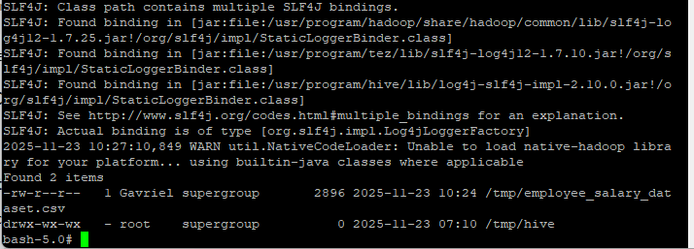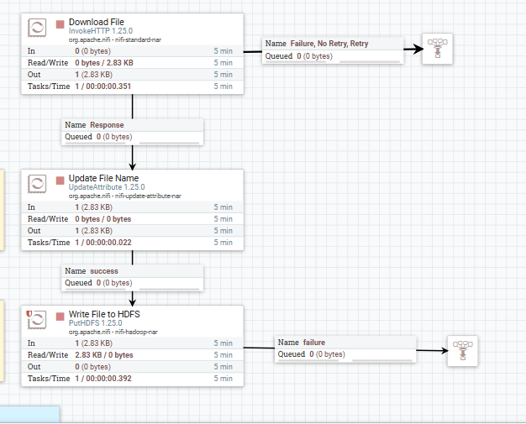
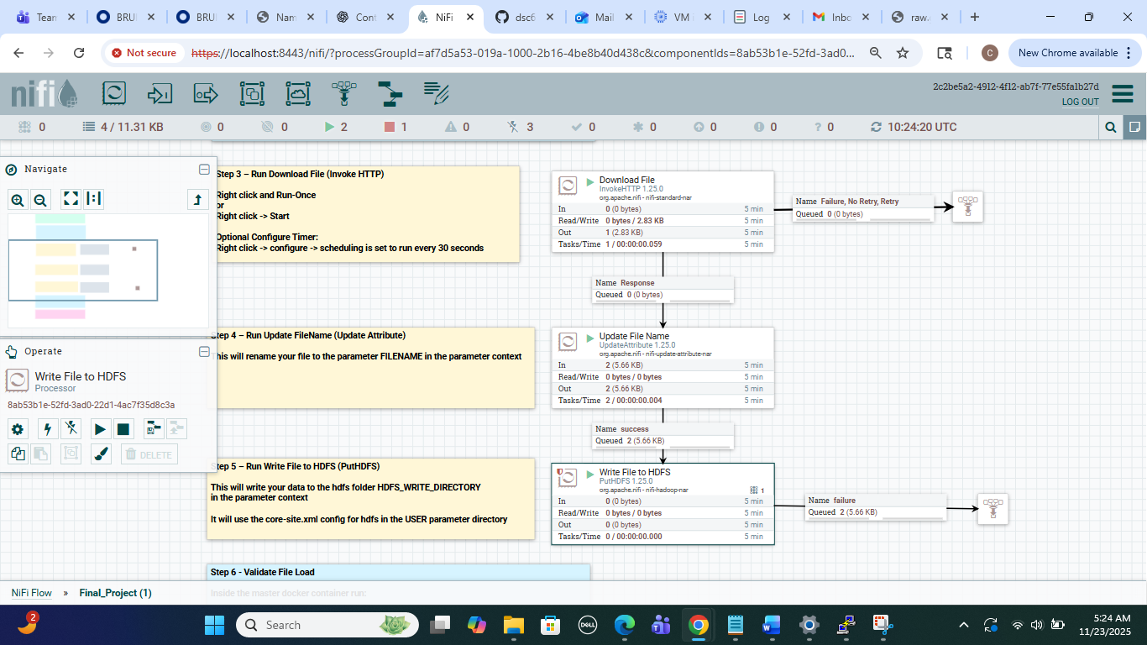
My NiFi flow uses three processors to ingest the dataset into HDFS. InvokeHTTP downloads the CSV file from my GitHub raw URL and creates the flow file. UpdateAttribute renames the file to a clean, consistent name so it can be stored and referenced properly. PutHDFS writes the file into the target HDFS directory, with the conflict strategy set to replace so the file can be overwritten if it already exists. The final HDFS screenshot showing employee_salary_dataset.csv inside /tmp confirms that the file was successfully written to HDFS and that the NiFi pipeline worked as intended.
Objective 2
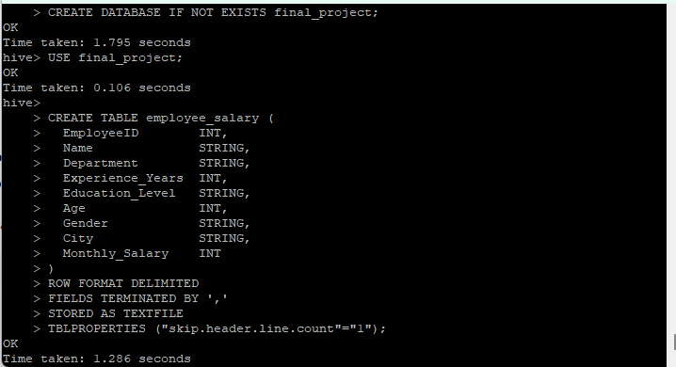

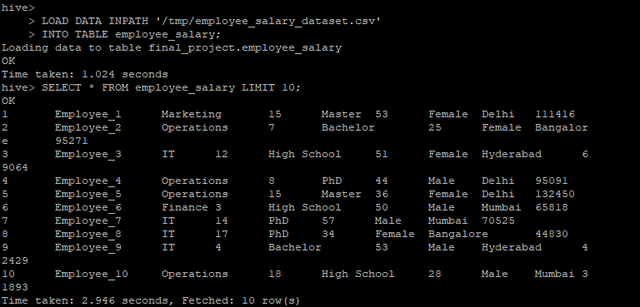

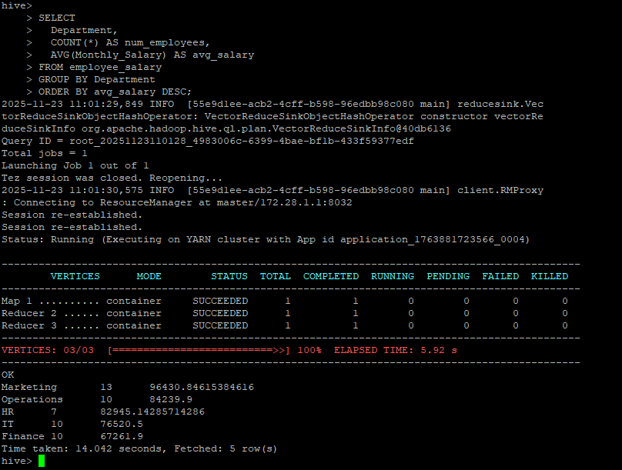
For my Hive table, I designed the schema to closely match the structure and semantics of the original CSV file. I stored EmployeeID, Experience_Years, Age, and Monthly_Salary as INT so they can be used easily in aggregations and statistical calculations (for example, average salary by department). Fields like Name, Department, Education_Level, Gender, and City are stored as STRING, since they are categorical or descriptive attributes rather than numeric measures. This schema keeps the data types simple but appropriate, while preserving all the information needed for analysis.
Objective 3
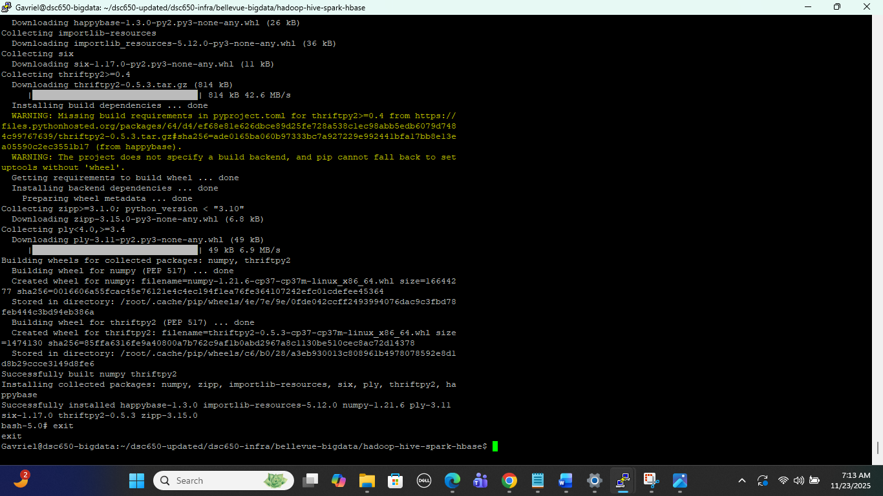
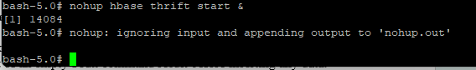
Installing Python packages such as numpy and happybase on the master and worker nodes is necessary because Spark jobs run Python code across the entire cluster. By ensuring all nodes have the same Python environment, the Spark ML script can execute without errors. Starting the HBase Thrift server is required so that Python code can communicate with HBase and write ML evaluation metrics into the HBase table.
Objective 4
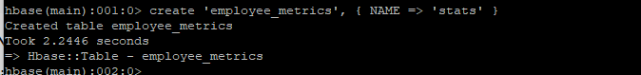
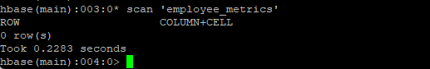
For my HBase table, I created a single column family named stats, which stores the machine learning metrics generated by my Spark job. The row key is chosen at insert time. I use a simple identifier such as "run1" to uniquely represent each model execution. This makes it easy to store and retrieve the evaluation metrics for each run. Using a short, meaningful row key also keeps lookups fast and aligns with HBase’s design for sparse, wide tables.
Objective 5
from pyspark.sql import SparkSession
from pyspark.ml.feature import VectorAssembler
from pyspark.ml.regression import LinearRegression
from pyspark.ml.evaluation import RegressionEvaluator
import happybase

def main():
# 1. Start Spark with Hive support
spark = (
SparkSession.builder
.appName("EmployeeSalaryML")
.enableHiveSupport()
.getOrCreate()
)

# 2. Use the Hive database and load data from the employee_salary table
spark.sql("USE final_project")
df = spark.sql(
"SELECT Experience_Years, Age, Monthly_Salary "
"FROM employee_salary"
)

# 3. Drop any rows with nulls in the columns we need
df = df.na.drop(subset=["Experience_Years", "Age", "Monthly_Salary"])

# 4. Assemble features into a single vector
assembler = VectorAssembler(
inputCols=["Experience_Years", "Age"],
outputCol="features"
)
data = assembler.transform(df).select("features", "Monthly_Salary")

# 5. Split into train and test sets
train_data, test_data = data.randomSplit([0.7, 0.3], seed=42)

# 6. Train a Linear Regression model to predict Monthly_Salary
lr = LinearRegression(
labelCol="Monthly_Salary",
featuresCol="features"
)
lr_model = lr.fit(train_data)

# 7. Evaluate the model on the test data
predictions = lr_model.transform(test_data)

evaluator_rmse = RegressionEvaluator(
labelCol="Monthly_Salary",
predictionCol="prediction",
metricName="rmse"
)
evaluator_r2 = RegressionEvaluator(
labelCol="Monthly_Salary",
predictionCol="prediction",
metricName="r2"
)

rmse = evaluator_rmse.evaluate(predictions)
r2 = evaluator_r2.evaluate(predictions)

print("=== Evaluation Metrics ===")
print(f"RMSE: {rmse}")
print(f"R2: {r2}")

# 8. Write metrics to HBase (employee_metrics table, stats column family)
connection = happybase.Connection("localhost")
connection.open()
table = connection.table("employee_metrics")

row_key = b"run1" # row key for this model run
table.put(
row_key,
{
b"stats:rmse": str(rmse).encode("utf-8"),
b"stats:r2": str(r2).encode("utf-8"),
},
)
connection.close()

# 9. Stop Spark
spark.stop()

if __name__ == "__main__":
main()
https://raw.githubusercontent.com/GavrielBlau/bigdata/refs/heads/main/employee_salary_ml.py
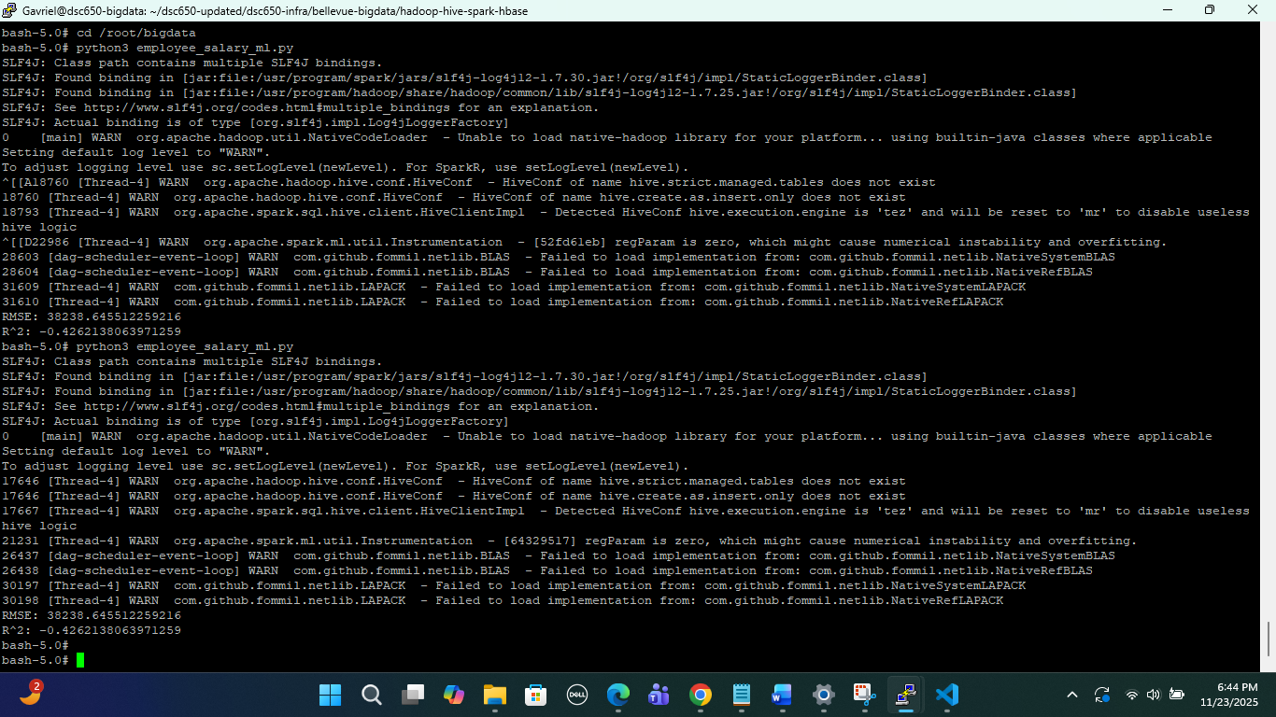
For my machine learning model, I used Linear Regression from Spark MLlib to predict an employee’s Monthly_Salary based on Experience_Years and Age. I chose linear regression because the target variable (salary) is continuous, and it’s a simple, well-understood baseline model for numeric prediction problems. The model was trained using a 70/30 train–test split on the salary dataset and evaluated with RMSE (root mean squared error) and R² (coefficient of determination). In my run, the model produced an RMSE of about 38,239 and an R² of about –0.43, which indicates that the model does not fit the data well (the negative R² means it performs worse than predicting the average salary). These results suggest that salary in this dataset is not well explained by just experience and age alone, and that a more complex model or additional features (such as department, city, or education level) would likely be needed to improve predictive performance.
Objective 6
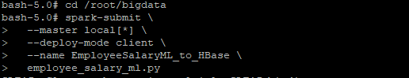
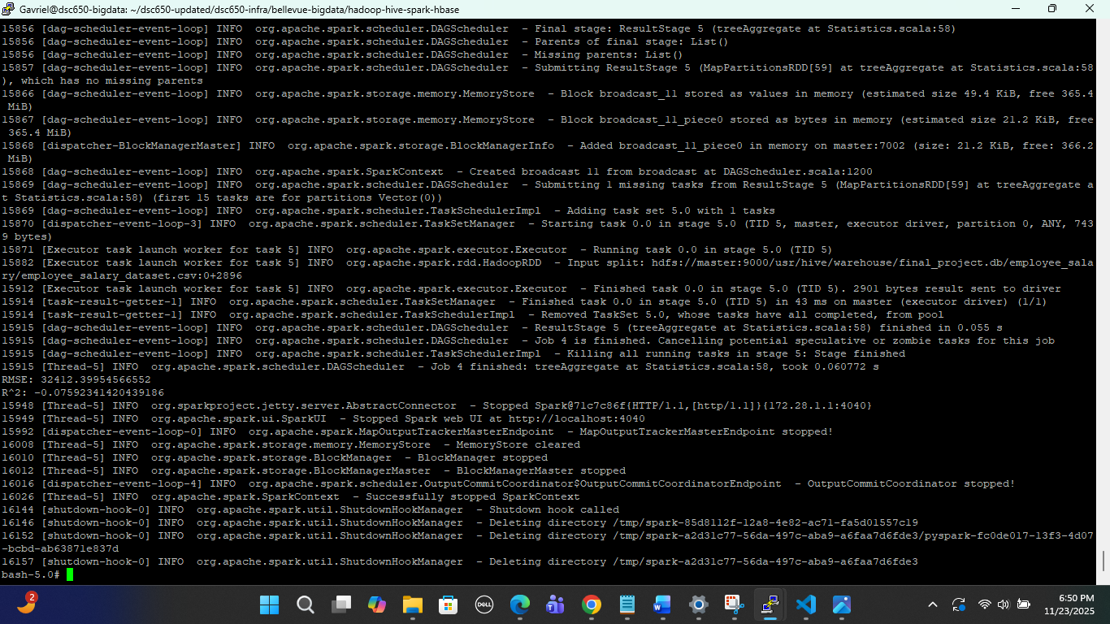
Objective 7
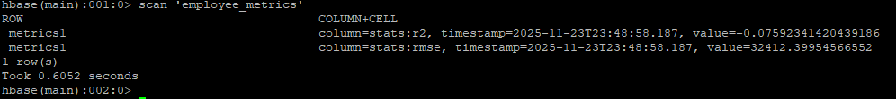
After training my Spark ML model, the script wrote the evaluation metrics into my HBase table employee_metrics using the happybase library. The metrics stored were RMSE and R², inserted under the column family stats with the row key metrics1. The populated HBase scan below shows both stats:rmse and stats:r2 with their computed values. This confirms that the machine-learning stage completed successfully and that the results were persisted to HBase.

Introduction
The goal of this project was to design and implement a complete end-to-end data pipeline using the major components of the Hadoop and Spark ecosystem. The pipeline integrates NiFi for ingestion, HDFS for distributed storage, Hive for warehousing and SQL querying, Spark MLlib for machine learning, YARN for resource management, and HBase for storing machine-learning evaluation metrics. The purpose of the project is to demonstrate how data can be ingested from an external source, processed across multiple big-data components, analyzed using Spark MLlib, and persisted into HBase as part of a real-world production-style workflow.

Dataset
For this project, I used the Employee Salary dataset, which originally came from Kaggle. Per the project requirements, I hosted the dataset in my own GitHub repository and ingested it into the pipeline using NiFi via its GitHub raw URL.
The dataset includes the following fields:
- EmployeeID
- Name
- Department
- Experience_Years
- Education_Level
- Age
- Gender
- City
- Monthly_Salary
This dataset is suitable for regression tasks, particularly predicting salary based on experience and age. After being pulled into NiFi, the dataset was written to HDFS and then loaded into a Hive managed table for structured querying and downstream Spark ML processing.
Pipeline Overview
The pipeline follows these stages:
- NiFi → HDFS
NiFi downloads the dataset from GitHub using InvokeHTTP, renames it using UpdateAttribute, and writes it into HDFS with PutHDFS. This provides automated ingestion of external data into the Hadoop cluster.
- HDFS → Hive
After stopping NiFi to conserve resources, the file is loaded into a Hive managed table called employee_salary stored in the final_project database. Hive is used for schema definition, data validation, and SQL queries.
- Hive → Spark MLlib
Spark reads the salary table to train a linear regression model predicting Monthly_Salary from Experience_Years and Age. The model is trained and evaluated in Python using PySpark.
- Spark → HBase
After training, the model’s evaluation metrics (RMSE and R²) are written into an HBase table employee_metrics under the stats column family. This demonstrates cross-system integration and storing results for downstream access.
- Verification
Completion is verified through HBase scans showing the written metrics, confirming the pipeline worked end-to-end.

Issues Encountered
Several challenges occurred during development.
First, NiFi repeatedly produced configuration errors, HDFS write failures, and conflicts related to file paths and overwritten filenames. The Hadoop containers do not preserve Hive or HBase metadata after restarts, requiring re-creation of tables. Second, PySpark was not installed in the cluster and installing an incompatible version caused silent failures. Matching the PySpark version to the cluster’s Spark version (3.0.0) resolved this. Finally, resource limitations on the VM required careful stopping of services (especially NiFi) to avoid performance issues. Despite these obstacles, each problem was diagnosed and resolved, and the pipeline achieved full functionality.

Conclusion
This project successfully demonstrates a complete big data pipeline integrating NiFi, HDFS, Hive, Spark MLlib, YARN, and HBase. Data flows smoothly from ingestion to model training and final persistence of results. The final output — a populated HBase table containing RMSE and R², confirms the pipeline works end-to-end. The project provided valuable hands-on experience with real distributed systems, debugging across multiple services, and understanding how data engineering tools interoperate in a production-style environment.

